Reflective space

Over the next month we would like you to take some time out to reflect with God on the questions and ideas below.
Covid Cloud
We recognise that the last 4 months with the Covid 19 crisis has been challenging for some, while for some others they have discovered new things and had some positive and enriching experiences.
Take a few moments to reflect on your own experience of the last 4 months
- What has changed for you?
- What has been most challenging?
- Where have you seen God at work?
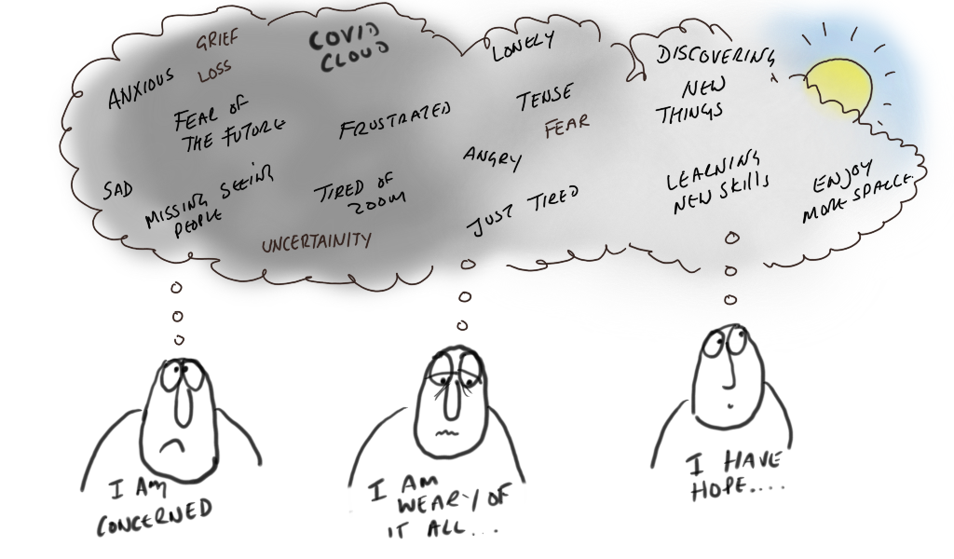

Mustard seeds
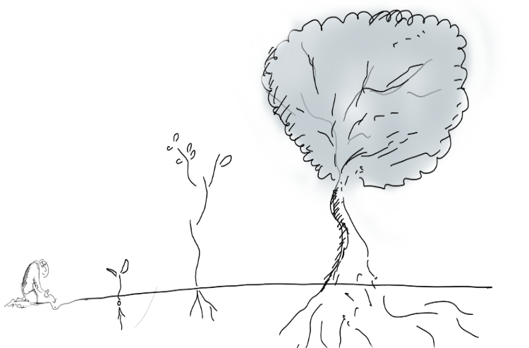
“Truly I tell you, if you have faith as small as a mustard seed, you can say to this mountain, ‘Move from here to there,’ and it will move. Nothing will be impossible for you. ”Matthew 17: 20

“The kingdom of heaven is like a mustard seed, which a man took and planted in his field. ³² Though it is the smallest of all seeds, yet when it grows, it is the largest of garden plants and becomes a tree, so that the birds come and perch in its branches.” Matthew 13:31-32
Is there a mustard seed of joy, hope and life that God has planted within you?
Take some time to reflect on what God might be inviting you to be and do in the next few weeks.
Balloon Questions
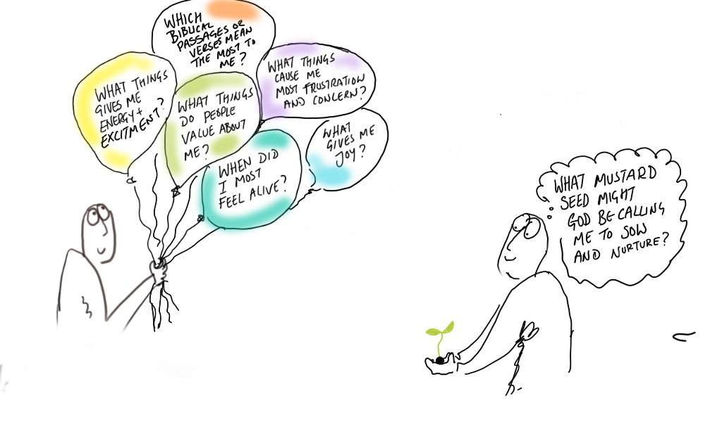
Take some time to reflect on the questions on the balloons below. These questions can help us get back to the things that bring us life, and the dreams and hopes God has planted within us.

