
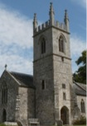
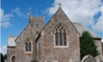
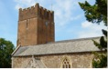
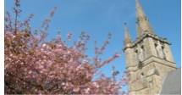
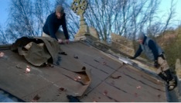


How you can make a
Lasting Gift to our Mission Area

???
Mission Area

A Lasting Gift

We welcome all gifts in wills, however large or small, and we promise to use your gift to make a difference in our Mission Area. We have been fortunate to receive such generous gifts in the past.
A generous legacy of £35,000 enabled us to hire an MA Youth and Families Worker.

The roof of St Peter’s was repaired thanks to a generous £10,000 legacy gift we received.

To request a free information pack, please visit www.churchlegacy.org.uk

You can also speak to the Treasurer in confidence about gifts in wills. Please contact them via 01542 837465 or admin@ourMA.org

3 Simple Steps

We encourage every adult
church member to:

- Make a will and review it regularly.
- Consider leaving a gift to our Mission Area.
- Request a free information pack.

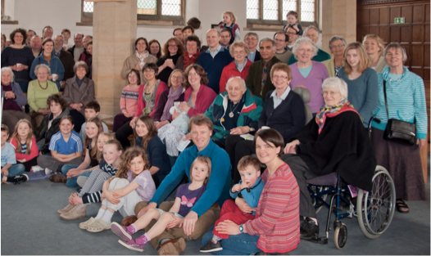
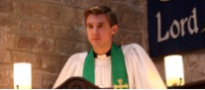

Our Legacy Policy

The policy of the MAC is to use gifts in wills to help fund significant development projects in the Mission Area. Since needs change over the years, we encourage church members to leave a gift in your will for the general purposes of the Mission Area, rather than for a restricted purpose.

The MAC will discuss with the executors the most appropriate use of the gift in the light of current projects and the donor’s known areas of interest in the church (e.g. children and youth, music, buildings).

Suggested wording for your will:

“ I give % of my residuary estate OR I give the sum of £ (pounds only) free of all taxes to the Mission Area Conference of the Mission Area of ??? in the Diocese of St Asaph for its general purposes, and I declare that the receipt of an officer of the Mission Area Conference shall be a sufficient discharge to my executors and trustees.”

We strongly advise you see a solicitor when writing or amending your will.

Dear Friends

It has always been a great encouragement whenever someone has left a gift in his or her will to our churches in the past.
It’s their testimony to the faithfulness, goodness and generosity of God and their thankfulness for the life of the Mission Area.
I want to encourage everyone in our church family, old and young to make a will, review it regularly, and consider the difference a gift in your will could make.
Thank you, Bob Smith – MA Leader

LORD our God, all this abundance that we have provided for building you a temple for your Holy Name comes from your hand, and all of it belongs to you.”
(1 Chronicles 29)

Your Faith, Your Gift

Many people give regularly to the mission and ministry of the Mission Area. We are stewards of everything we own, not just our income and gifts in wills are a natural part of that giving.
They are a valuable and lasting way to invigorate the life of ??? Mission Area and transform its future.

A gift in your will can be an expression of your gratitude and thanksgiving towards God, and can help keep your church alive, and transform its future.
The Mission Area Conference (MAC) has written a Legacy Policy confirming that, however large or small, they will use your gift to make a real difference to our Mission Area.

