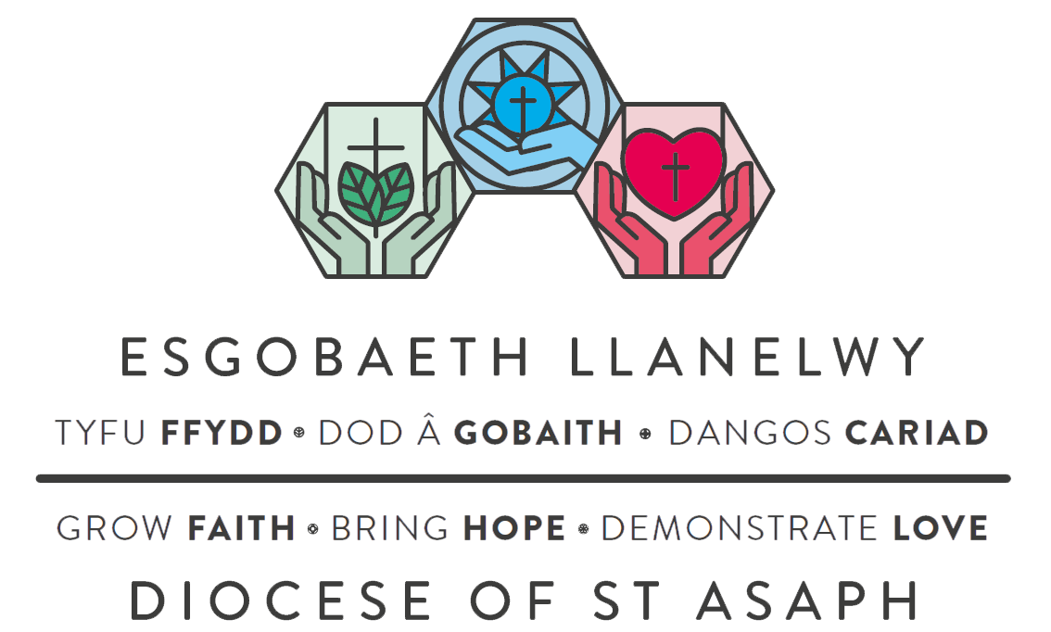

Guidance Notes to accompany
Faith, Hope, Love: The Course

Spring 2022

Session One: Telling our Stories

Welcome Catrin and Ben Lines
Introduction Bishop Gregory reading Hebrews 12: 1-3
Part One - Personal stories

A short video in which Linda and Keith Roberts from St Peter’s Church in Holywell tell us a little about their Christian journey, followed by a time of reflection in small groups using the following questions [pause the film at this point to discuss]:

- How did you become a Christian?
- Describe one person or thing that has encouraged or nurtured your Christian faith.

Part Two - Shared stories

A second video in which Lind and Keith tell us about their experience of church, followed by another time for discussion using the following questions [pause the film at this point to discuss]:
:
- Describe something that you particularly like about your church.
- Give an example of how your church or a church that you know demonstrates faith, hope and love to the wider community?

Summation Catrin and Ben

Closing Prayer together, using the diocesan prayer which will be on screen:
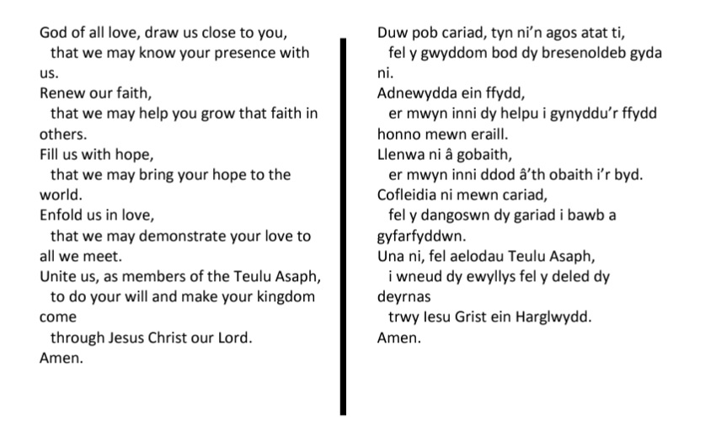
Available to download at https://dioceseofstasaph.org.uk/lent/
Session Two: Faith and How it Shapes our Lives

Welcome Catrin and Ben Lines
Introduction Bishop Gregory reading 1 Corinthians 10-11
Part One - Personal faith

A short video in which Jampa King and Alyson Evans from Bala tell us a about what faith means to them, followed by a time of reflection in small groups using the following questions [pause the film at this point to discuss]:

- What aspects of the Christian faith are particularly important to you?
- What do you struggle with?

Part Two - Shared faith

A second video in which Jampa and Alyson tell us about the things they have in common with the people they worship with, followed by another time for discussion using the following questions [pause the film at this point to discuss]:

- What do you think we share with other people in our church or wider family of churches?
- In what ways do our beliefs affect the way we live our lives?

Summation Catrin and Ben

Closing Prayer together, using the diocesan prayer which will be on screen:
Available to download at https://dioceseofstasaph.org.uk/lent/

Session Three: Hope and the Expectation of Change

Welcome Dan Morgan and Cass Meurig-Thomas
Introduction Bishop Gregory reading Ephesians 1: 17-19
Part One - Personal hopes

A short video in which Kyle Boyd and Joella Sharples from Hope Street, Wrexham share some of their hopes, followed by a time of reflection in small groups using the following questions [pause the film at this point to discuss]:
- Why is hope important?
- What brings you hope at the moment?

Part Two - Shared hopes

A second video in which Kyle and Joella tell us about how their church attempts to nurture hope, followed by another time for discussion using the following questions [pause the film at this point to discuss]:

- What has your church done in the past to bring hope to your wider community?
- What else might you do to nurture hope in your area?

Summation Dan and Cass

Closing Prayer together, using the diocesan prayer which will be on screen:
Available to download at https://dioceseofstasaph.org.uk/lent/

Session Four: Love and the Power to Transform

Welcome Dan Morgan and Cass Meurig-Thomas
Introduction Bishop Gregory reading Romans 12: 9-13
Part One - Personal loves

A short video in which Jessica Crane, Michael Stevenson and Emily-Rose Hatton-Hunter from Towyn talk about things they love, followed by a time of reflection in small groups using the following questions [pause the film at this point to discuss]:
- Why do you think love is important?
- What do you particularly love?

Part Two - Shared loves

A second video in which Jessica, Michael and Emily-Rose tell us about how their church demonstrates love, followed by another time for discussion using the following questions [pause the film at this point to discuss]:
- What do you think a loving church should look like?
- What might a loving church feel like?

Summation Dan and Cass

Closing Prayer together, using the diocesan prayer which will be on screen:
Available to download at https://dioceseofstasaph.org.uk/lent/

Session Five: Choice and the Creation of New Possibilities

Welcome Dan Morgan and Cass Meurig-Thomas
Introduction Bishop Gregory reading 2 Corinthians 3:16-18
Part One - Personal choices

A short video in which Mary James, Wendy Gardiner, Jean Bailey and Miles James from Newtown talk about choices they have made and how they have impacted on their lives or lives of others, followed by a time of reflection in small groups using the following questions [pause the film at this point to discuss]:
- Describe a choice that you made that affected your life positively or negatively.
- In what ways might our faith affect our choices?

Part Two - Shared choices

A second video in which Jean, Wendy, Mary and Miles tell us about how the choices their church has made has affected their common life and their Ministries within their wider community, followed by another time for discussion using the following question [pause the film at this point to discuss]:

- What choice or choices does your church need to make if it is to truly reflect faith, hope and love in your worship, shared life and community outreach?

Summation Dan and Cass

Closing Prayer together, using the diocesan prayer which will be on screen:
Available to download at https://dioceseofstasaph.org.uk/lent/

